Superstore Sales

# SKETCHES

[PASTE IN THE IMAGE(S) OF YOUR CHARTS TO REFLECT YOUR SKETCHES FOR THE QUESTIONS]

Q1. What is the most profitable City in the State of Tennessee?

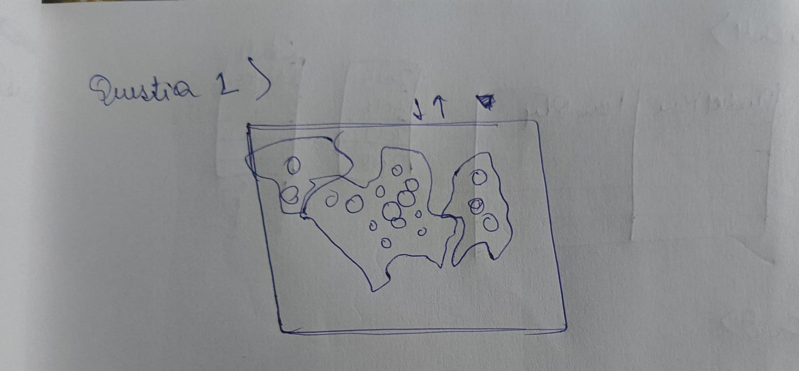

Q2. What’s the average annual profit for that city across all years in that city?

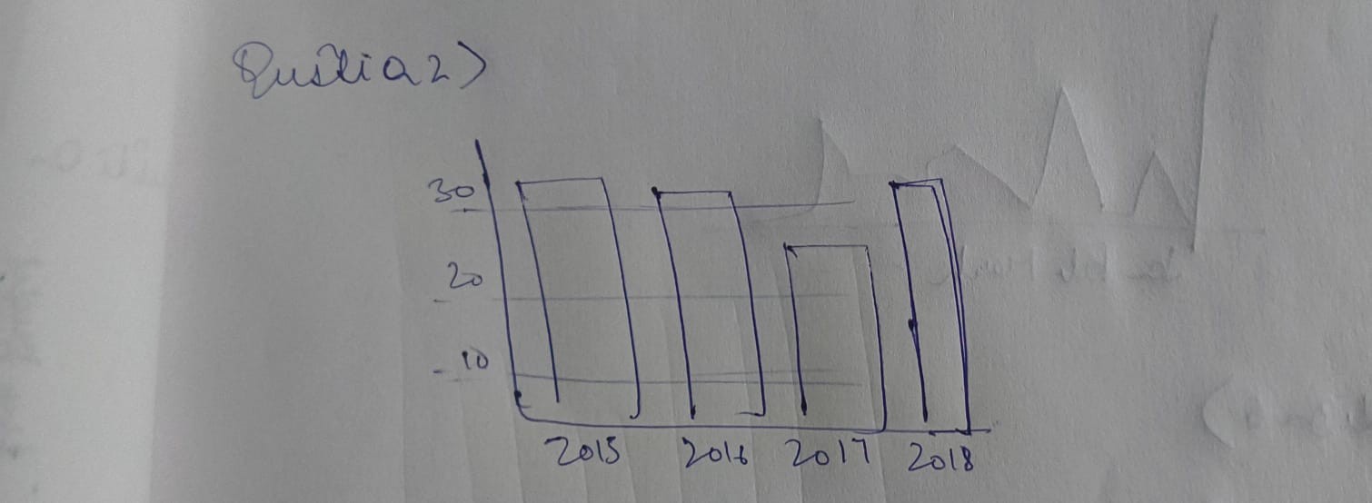

Q3. What’s the most profitable product category in Iowa?

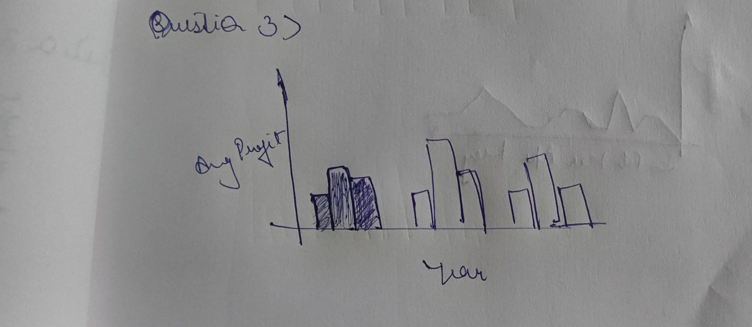

Q4. What is the most popular product in that category in 2016?

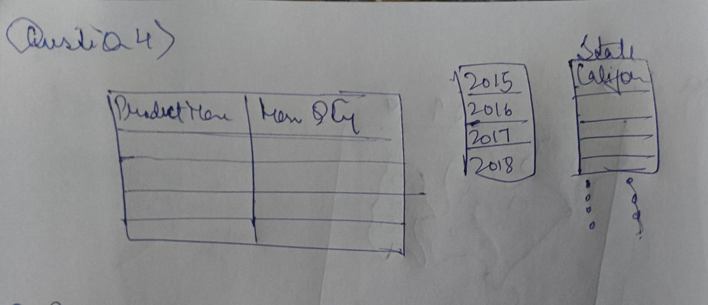

Q5. What was the most profitable month in 2018 overall?

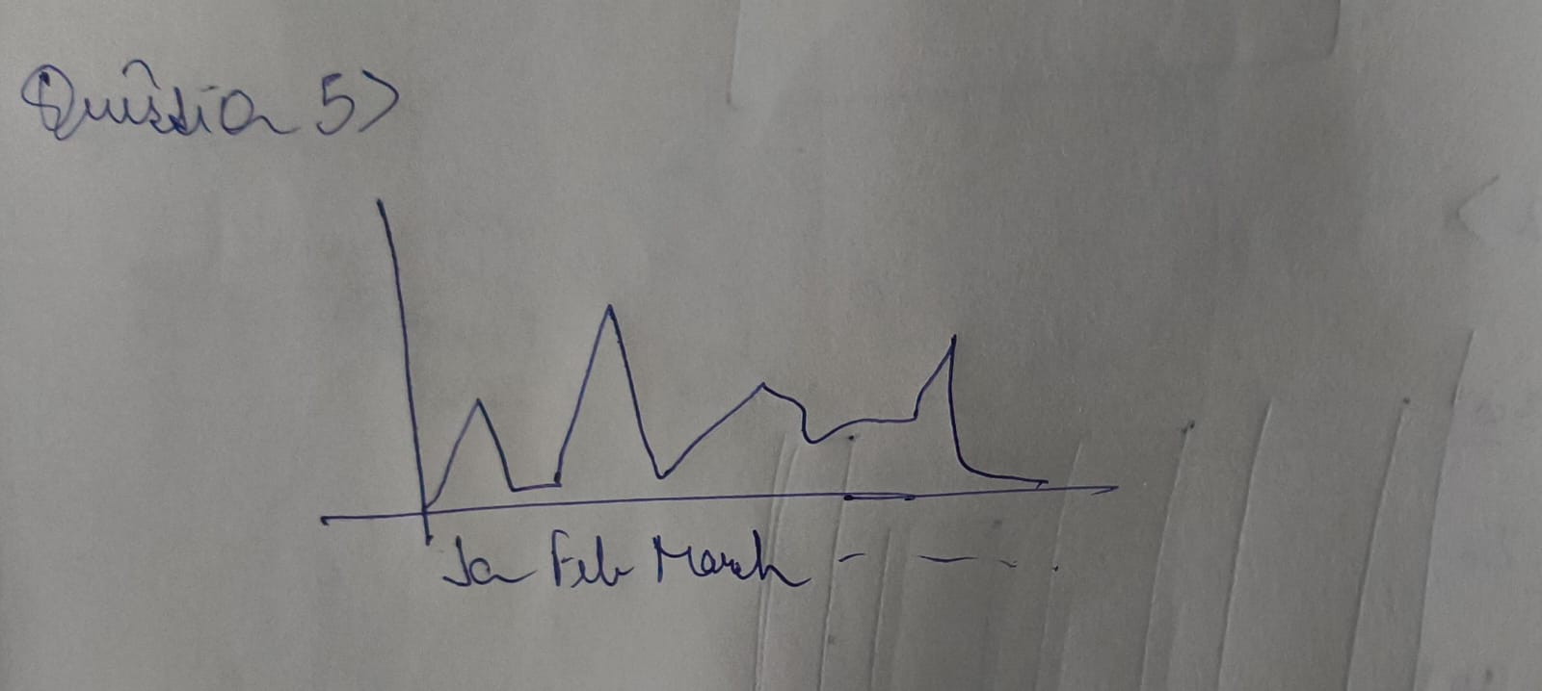

Q6. How widely did monthly profits vary in 2018?

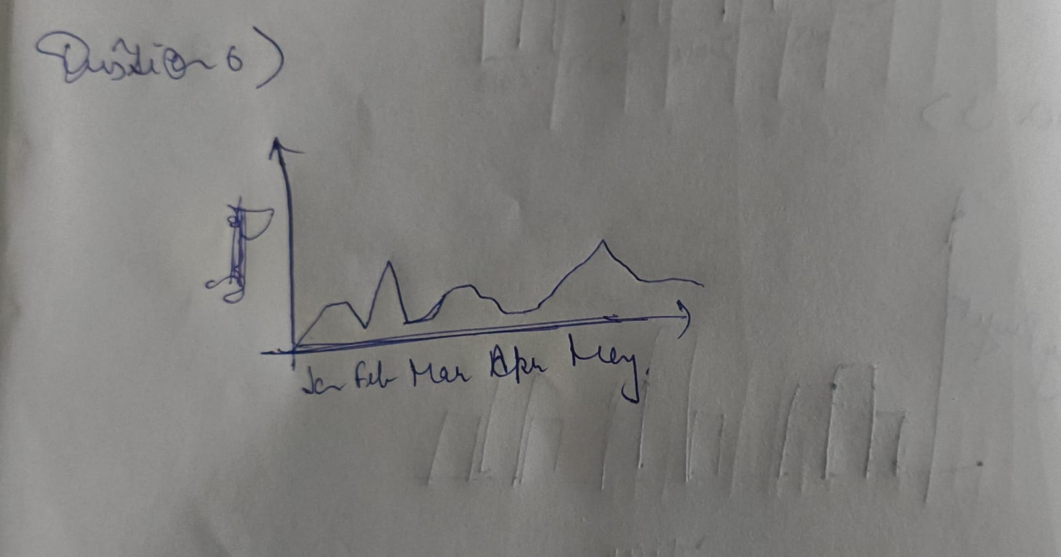

# WIREFRAMES

[PASTE IN THE IMAGE(S) OF YOUR WIREFRAMES FOR THE QUESTIONS]

Q1.What is the most profitable City in the State of Tennessee?

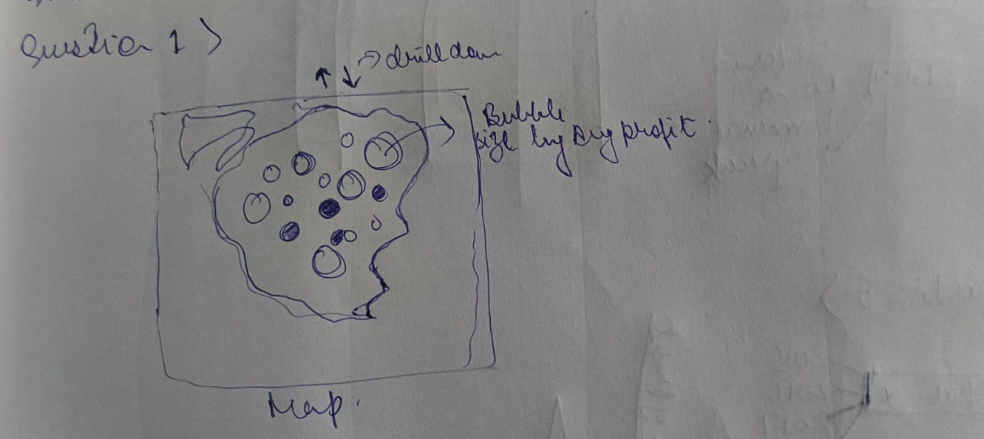

Q2. What’s the average annual profit for that city across all years in that city?

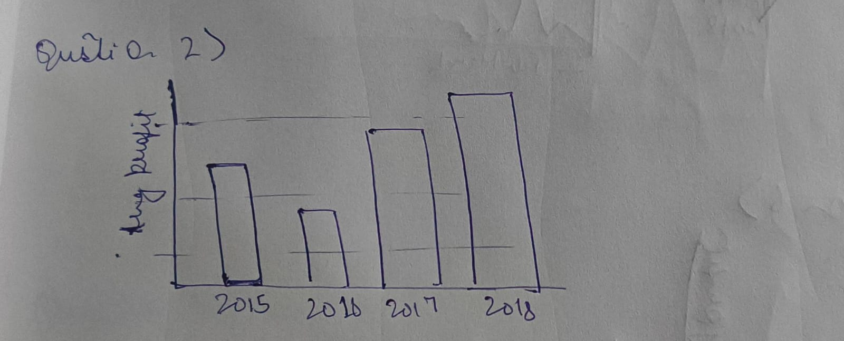

Q3.What’s the most profitable product category in Iowa?

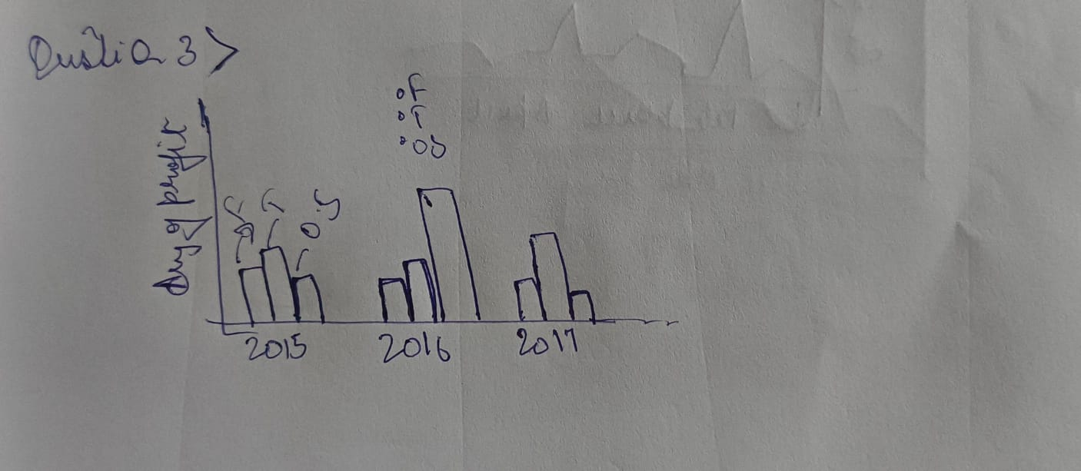

Q4.What is the most popular product in that category in 2016?

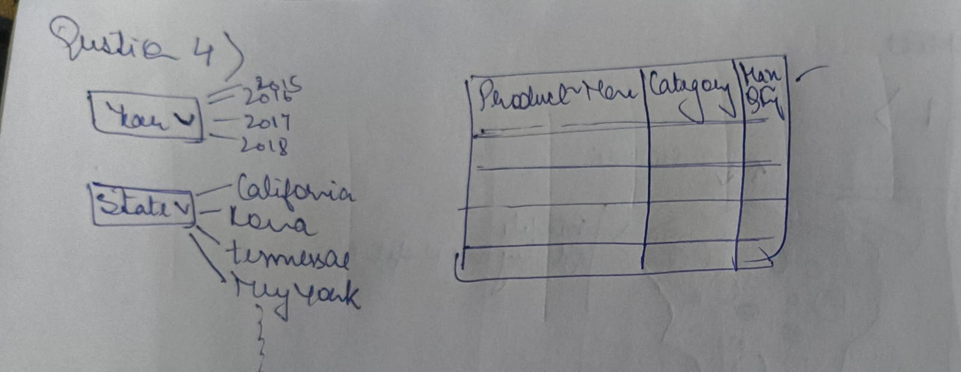

Q5.What was the most profitable month in 2018 overall?

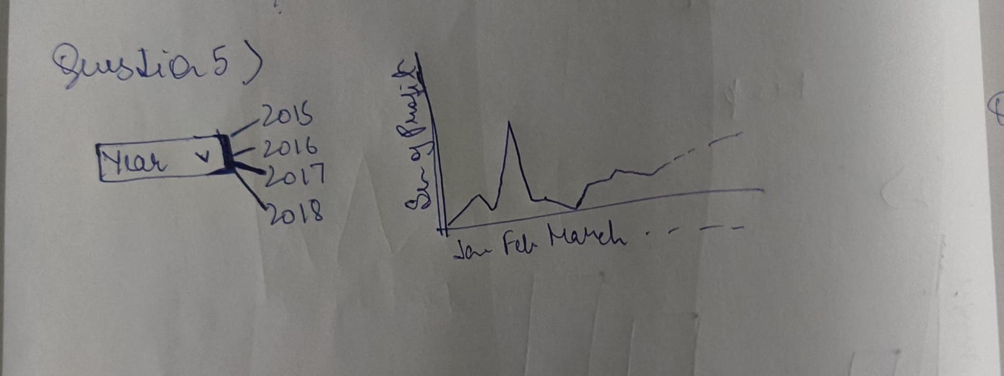

Q6.How widely did monthly profits vary in 2018?

